**LAND IMPACT OF GREENFIELD INTERNATIONAL AIRPORT PROJECT OF GREAT NICOBAR ISLAND**



**Cluster Innovation Centre**

**University of Delhi**

August 2024 – December 2024

Internal Assessment Report submitted for the paper

**Environmental Management**

Introduction 2

Project Information 2

**Airport Plan:** 2

**Runway and Taxiway Dimensions:** 3

**Apron Dimensions:** 4

**Summarized Airport Facilities:** 4

Airport Land Use 4

**Aeronautical Facilities** 5

**Non-Aeronautical Facilities** 5

**Total Land Area** 5

**Project Area and Topographic Map** 5

Environmental Impact of Land Use 6

**1. Deforestation and Habitat Displacement** 6

**2. Soil Degradation and Erosion** 7

**3. Impact on Water Resources** 7

**4. Land Use Change** 7

**5. Mitigation Measures** 7

Conclusion 8

# **Introduction**

The Greenfield International Airport project is one of the most significant infrastructure developments planned in the region. Airports are vital hubs for economic growth, connecting people and businesses across the globe. As India continues to grow economically and socially, the need for new, larger, and more efficient airports has become increasingly apparent. This project aims to meet the demands of increasing air traffic and improve connectivity in the region.

However, like all large-scale infrastructure projects, the construction of the Greenfield Airport brings with it several environmental and social considerations. Among these, the impact on land use is one of the most critical aspects that must be addressed to ensure sustainable development. The construction process involves a substantial amount of land, including airside facilities (runways, taxiways, aprons), landside facilities (terminal buildings, vehicle parking), and other essential infrastructure.

This report will focus on the specific environmental impact related to land use and alteration, which forms a core aspect of this project. Additionally, it will explore the project's technical details, its potential environmental consequences, and suggested mitigation strategies to minimize the disruption to the surrounding environment.

# **Project Information**

The Greenfield International Airport will cater to both domestic and international traffic, with facilities designed to accommodate commercial aircraft, cargo, and military operations. The airport layout features runways, taxiways, aprons, terminals, and various aeronautical and non-aeronautical facilities.

## **Airport Plan:**

* Figure 1 below presents the overall layout and master plan of the Greenfield International Airport. The airport plan shows the positioning of key facilities such as the runways, taxiways, aprons, terminal buildings, and other operational areas.

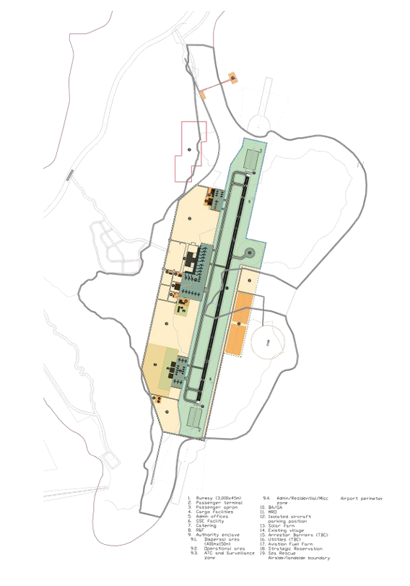

Fig.1

## **Runway and Taxiway Dimensions:**

* The main runway will have a length of 3000 meters and a width of 45 meters, which is designed to accommodate Code 4F aircraft as per ICAO standards. The airport will have provisions for expanding the runway to 4000 meters if needed in the future.
* The parallel taxiway is proposed to have a length of 3800 meters and a width of 25 meters, allowing smooth movement of aircraft to and from the runway.
* Figure 2 provides a visual representation of the proposed runway, which will be 3000 meters in length and 45 meters wide, capable of handling Code 4F aircraft. Additionally, the parallel taxiway measuring 3800 meters in length will ensure efficient aircraft movement to and from the runway.

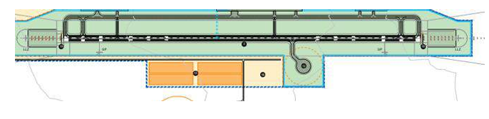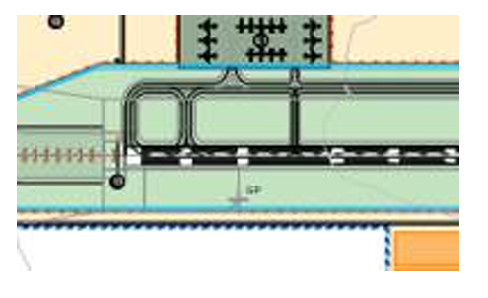

Fig.2

## **Apron Dimensions:**

* The commercial aircraft apron will have an area of 1,16,000 sqm.
* Cargo and MRO (Maintenance, Repair, and Overhaul) aprons will span 15,950 sqm.
* The general aviation apron will have an area of 18,500 sqm.

## **Summarized Airport Facilities:**

* The airport is expected to handle 9 flights per peak hour.
* The passenger terminal building is designed to handle 1036 passengers per hour.
* A total area of 24,864 sqm is allocated for the terminal building.

# **Airport Land Use**

Land use in the airport is divided into aeronautical and non-aeronautical facilities. The airside facilities, such as runways and taxiways, consume a large portion of the land. At the same time, landside facilities focus on passenger services, commercial activities, and essential support structures. These categories have specific land utilization patterns that are crucial for understanding the project's overall environmental footprint.

## **Aeronautical Facilities**

The table below outlines the land allocation for aeronautical facilities:

|  |  |  |
| --- | --- | --- |
| Item | Area (sqm) | Hectares |
| Runway (3000x45 m) | 2,40,200 | 24.02 |
| Taxiway system | 1,65,150 | 16.515 |
| Commercial Aircraft Apron | 1,16,000 | 11.6 |
| Passenger Terminal Building | 24,864 | 2.4864 |
| ATC and Technical Building | 6000 | 0.6 |
| Cargo Aircraft & MRO Apron | 15,950 | 1.595 |
| General Aviation Apron | 18,500 | 1.85 |
| Ground Support Equipment Area | 9,185 | 0.9185 |
| Isolated Aircraft Parking | 10,080 | 1.008 |
| Defence Enclave and Expansion | 3,06,000 | 30.6 |

## **Non-Aeronautical Facilities**

The non-aeronautical facilities at the airport are just as important, as they support the overall functioning of the airport. They include:

|  |  |  |
| --- | --- | --- |
| Item | Area (sqm) | Hectares |
| Vehicle Parking | 60,000 | 6 |
| Sewage Treatment Plant | 8,400 | 0.84 |
| Fuel Farm | 11,000 | 1.1 |
| Solar Farm | 1,33,200 | 13.32 |
| Access Roads | 34,000 | 3.4 |
| Peripheral Roads | 1,26,000 | 12.6 |
| Admin & Health Organization | 19,200 | 1.92 |

## **Total Land Area**

The total land allocated for aeronautical and non-aeronautical facilities is approximately 169.44 hectares, with a significant proportion of the land dedicated to runways, taxiways, aprons, and terminal buildings.

## **Project Area and Topographic Map**

The project area overlaid on the topographic map, shown in Figure 3, highlights the geographical terrain and land use considerations for the airport's development. This helps in understanding the impact of the construction on the natural landscape.

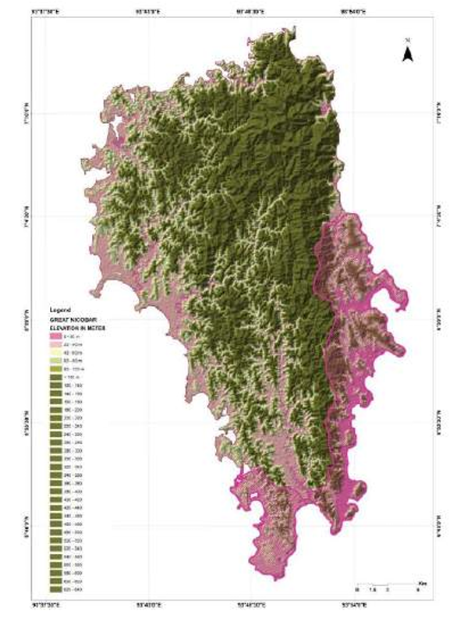

Fig.3

# **Environmental Impact of Land Use**

Land development for large infrastructure projects such as airports inevitably leads to significant environmental changes. These changes primarily impact land use, biodiversity, soil quality, and surface water systems. The environmental concerns surrounding the Greenfield International Airport project include:

## **1. Deforestation and Habitat Displacement**

The construction of runways, taxiways, and terminal facilities requires clearing vast areas of land, potentially leading to deforestation. The loss of trees and vegetation disrupts the habitats of various species of flora and fauna, leading to habitat fragmentation and biodiversity loss. In some cases, the loss of habitats can force species to migrate or lead to a decline in population due to the destruction of their natural environment.

## **2. Soil Degradation and Erosion**

The large-scale excavation and earth-moving activities required for site preparation can lead to soil degradation. The removal of topsoil can decrease soil fertility, affect agricultural productivity, and cause erosion. Additionally, soil compaction from construction machinery can reduce water infiltration, further exacerbating erosion and increasing the likelihood of landslides in vulnerable areas.

## **3. Impact on Water Resources**

The airport construction process may have adverse effects on local water bodies. The removal of vegetation and soil compaction could increase surface runoff, leading to the contamination of nearby rivers and lakes. This runoff may carry construction materials, chemicals, and other pollutants into the water system, adversely affecting water quality.

In addition, the introduction of large impervious surfaces, such as runways and aprons, may interfere with natural groundwater recharge processes. Altering the natural drainage system could also affect the surrounding wetlands, which are important ecosystems that help in water purification and flood control.

## **4. Land Use Change**

The conversion of land from its natural state to infrastructure introduces long-term changes in the land-use pattern. The development of airports changes agricultural land, forests, or wetlands into paved areas for aviation operations, leading to a permanent loss of natural land resources. Moreover, the land use changes could increase the urban heat island effect due to the increased surface temperatures of paved areas compared to natural landscapes.

## **5. Mitigation Measures**

To reduce the environmental impact of the Greenfield International Airport on land use, several mitigation strategies should be implemented:

* **Reforestation and Landscaping**: A compensatory reforestation program should be developed to plant trees in areas affected by construction activities. Native species should be prioritized to restore habitats and preserve biodiversity.
* **Soil Conservation**: Erosion control measures, such as silt fences and vegetation buffers, should be employed to prevent soil degradation and maintain soil quality. Additionally, the use of sustainable agricultural practices in the surrounding areas will help to minimize the effects on local farming communities.
* **Water Management**: Constructing artificial wetlands and water retention basins could help manage runoff and maintain groundwater recharge. Stormwater management systems should be put in place to prevent flooding and reduce the contamination of nearby water bodies.
* **Minimizing Land Disturbance**: The construction plan should aim to minimize land disturbance by limiting the project footprint, concentrating on areas already affected by human activities, and avoiding ecologically sensitive regions. This would help in conserving local ecosystems and reducing the impact on biodiversity.

# **Conclusion**

The Greenfield International Airport project is a crucial development for regional connectivity and economic growth. However, the project must account for the environmental consequences associated with its construction, particularly concerning land use. By adopting effective land use and conservation strategies, the adverse effects on the environment can be mitigated.

Balancing the need for infrastructure with environmental sustainability is critical for ensuring the long-term viability of both the airport and the surrounding region. Therefore, a comprehensive environmental management plan should be integral to the project’s development, helping to reduce its land-related impacts and ensuring a sustainable future.